**Docker Installation**

* When we install docker we get two major components
  + docker client:
    - A command line to interact with docker engine
  + docker engine: This is collection of multiple components
    - Orchestration
    - Docker daemon
    - Runtime

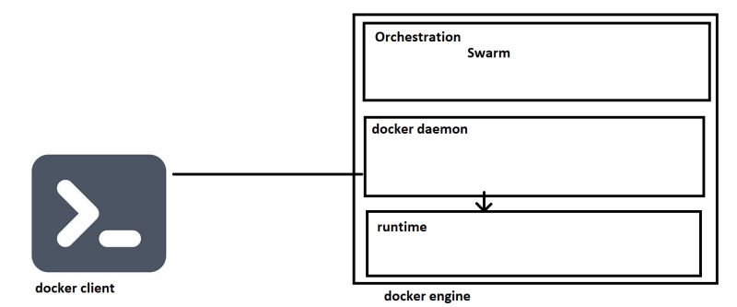

* to play with docker commands
  + manual --help
  + cheatsheet

Linux VM:

Docker can be installed by following instructions over here <https://docs.docker.com/engine/install/>

script based installation <https://get.docker.com/>   
curl -fsSL <https://get.docker.com> -o get-docker.sh  
sh get-docker.sh

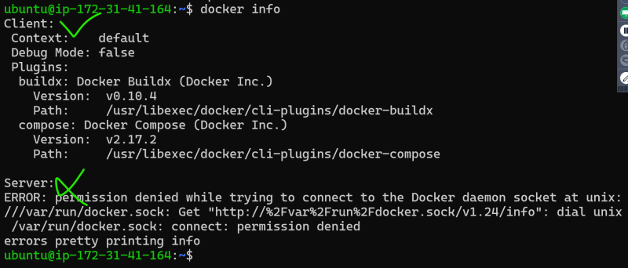

Docker allows communication to the unix socket for the users who belong to docker group. so lets add current user to docker group sudo usermod -aG docker <username>. logout and login

Now execute docker container run hello-world  
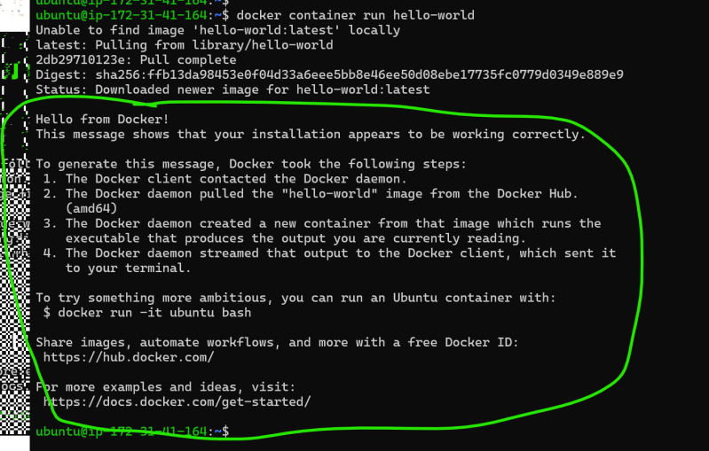

**terms To be aware of**

* containerd
* runc
* libcontainer
* oci
* docker shim
* appc
* grpc
* rkt containers

**Cheatsheets**

* <https://docs.docker.com/get-started/docker_cheatsheet.pdf>
* <https://dockerlabs.collabnix.com/docker/cheatsheet/>